**Project Design Phase**

**Solution Architecture**

|  |  |
| --- | --- |
| Date | 26 June 2025 |
| Team ID | SRGECVIP20251570 |
| Project Name | Revolutionizing Liver Care : Predicting Liver Cirrhosis using Advanced Machine Learning Techniques |
| Maximum Marks | 4 Marks |

**Solution Architecture:** Liver Cirrhosis Prediction using Machine Learning

This solution architecture outlines a web-based liver cirrhosis risk prediction system using machine learning.  
The system is designed to facilitate early detection, non-invasive analysis, and clinical decision support.  
It connects multiple layers including data collection, preprocessing, model inference, interpretability, and visualization.

Main Components:

1. User Interface (Web App):

- Allows doctors to input patient clinical data (e.g., age, enzyme levels, test results)

- Displays prediction results and risk scores

- Provides feature contribution visuals for explainability

2. Backend Server (Flask/Streamlit API):

- Handles incoming patient data

- Preprocesses data (normalization, encoding)

- Sends data to the ML model for prediction

- Returns results and SHAP values

3. Machine Learning Engine:

- Trained on clinical datasets with labeled cirrhosis outcomes

- Uses algorithms like Random Forest, XGBoost

- Integrated with SHAP for explainability

4. Data Storage:

- Stores patient submissions temporarily or securely for analysis

- Could use local storage or cloud (AWS S3, Firebase, etc.)

**Example - Solution Architecture Diagram:**

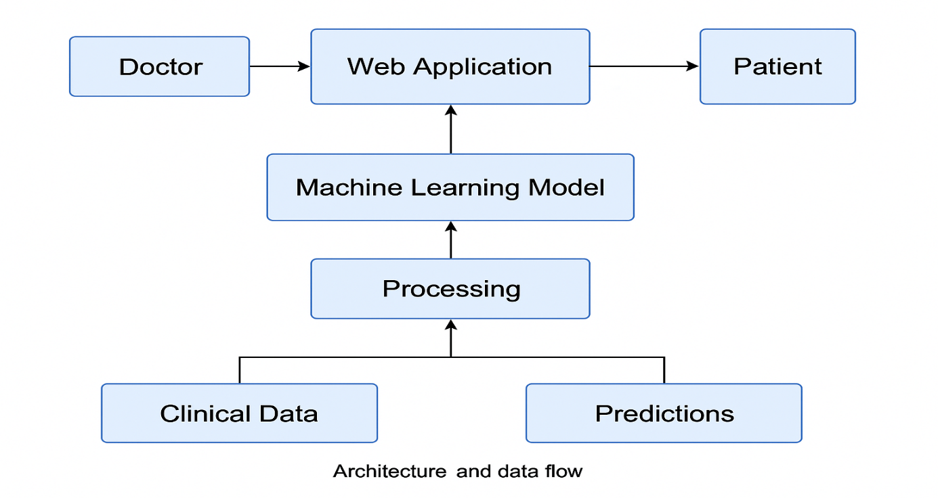

*Figure 1: Architecture and data flow of the patient application*